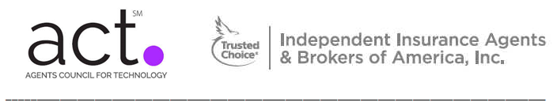
Agents Council for Technology
Schedule & Agenda
Feb 18-20, 2015
Embassy Suites Downtown Convention Center –
513 South Florida Avenue, Tampa, FL

Dress: Business Casual for all sessions Badges: Pick up outside ACT meeting room
Tent cards: Pick up just inside meeting room

Overall Schedule of Meetings & Events

** ACT Meeting conference room: Bayside Ballroom **

Wednesday, Feb 18
1:00 PM – 4:50 PM ACT Meeting, Day 1 (Agenda details next page)
5:30 PM - 7:30 PM Networking reception – Embassy Suites Manager’s Reception – Atrium

Thursday, Feb 19
7:45 AM - 8:45 AM Hotel-provided Breakfast – Embassy Suites
8:45 AM – 12:00 PM ACT Meeting, Day 2 (Agenda details next page)
12:00 AM – 1:00 PM ACT/AUGIE Lunch and Networking
1:00 PM – 5:00 PM AUGIE Meeting, Day 1
5:30 PM - 7:30 PM Networking Reception – Embassy Suites Manager’s Reception – Atrium
7:00 PM - 9:00 PM ACT/AUGIE Dinner – Gandy Ballroom

Friday, Feb 20
7:45 AM - 8:45 AM Hotel-provided Breakfast – Embassy Suites
8:45 AM – 12:00 PM AUGIE Meeting, Day 2
12:00 PM – 1:00 PM Box Lunch
12:30 PM Attendees can depart for flights home

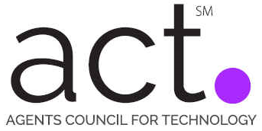
ACT Agenda – Day 1

Conference Room: Bayside Ballroom

Wednesday, February 18 (1:00—4:50 PM)
- Chair’s Welcome, Antitrust Statement, Meeting Opening
(1:00 - 1:15 PM)
Jim Armitage (Arroyo Insurance Services) & Ron Berg (ACT)

- The State of Our Industry – Michael Jans
(1:15 - 2:15 PM)

- Digital Change Is Hard, But We Have To Be Fast Dave Kopetzky, Dale Steinke - Safeco
(2:15 – 3:30 PM)

** Break ** (3:30-3:45 PM)

- The Customer Experience – Recommendations for Agents
(3:45 – 4:30 PM)

- Open discussion on Day 1 of the ACT meeting, setting up Thursday morning
(4:30 – 4:50 PM)
Jim Armitage, Ron Berg, & full group

(ACT Meeting, Day 2 Agenda, next page)

ACT Agenda – Day 2

Conference Room: Bayside Ballroom

Thursday, February 19 (8:30—12:00 PM)
- Welcome, Day 2 order
(8:30 – 8:40 AM)
Jim Armitage (Chair, Arroyo Insurance Services) & Ron Berg (ACT)
- The Business Model of Cyber Crime – Paul Viollis
(8:40 – 9:45 AM)

** Break ** (9:45-10:00 AM)

- Interactive Session – What Young Agents Talk About Boyd McGehee, Alex Dopazo, Jill Roth, Lindsey Shank (10:00 – 11:15 AM)

- Personal Lines Sales & Service Trends EZLynx – Brady Polansky
(11:15 – 11:50 AM)

- Open items, additional discussion, Meeting Takeaways
(11:50 AM – 12:00 PM)
Jim Armitage, Ron Berg, & full group

(See next page for Future ACT Meeting details)

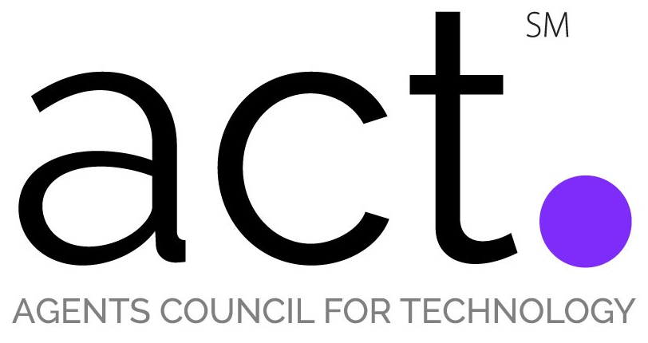

Times & Places for Next Meetings

May, 19-20 2015 ACT Meeting
ACT meeting to be held in conjunction with AUGIE. Aartrijk Brand Camp will also be held in the days prior to the ACT & AUGIE meetings. To be held at the Magnolia Hotel in St. Louis, MO.
** Agenda and registration information forthcoming prior to meeting.

Oct 2, 2015 ACT Meeting
This ACT meeting will take place in conjunction with the IIABA Fall Leadership Conference running from Sep 30-Oct 4 at The Roosevelt New Orleans Hotel in New Orleans, LA. There will be an ACT Dinner the evening of Thu Oct 1, with the ACT Meeting running the full day of Fri Oct 2.
** Agenda and registration information forthcoming prior to meeting.

February, 2016 ACT Meeting
This ACT meeting to be held in conjunction with AUGIE. The meetings will take place Feb 17-19 at the
Embassy Suites Scottsdale in Scottsdale, AZ.
** Agenda and registration information forthcoming prior to meeting.

