E&O Program Conference 2022

Kansas City Marriott Downtown, Kansas City, MO

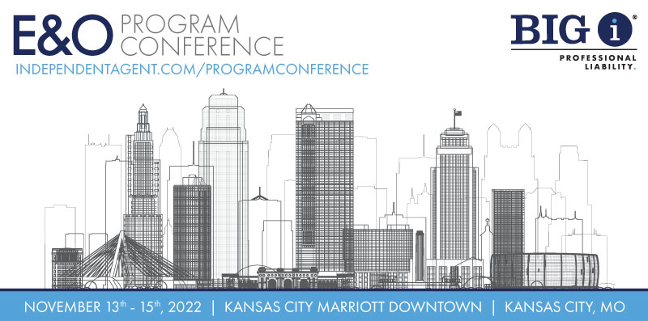

|  |  |  |  |
| --- | --- | --- | --- |
| **Date** | **Time** | **Event** | **Location** |
| **Sunday**  **November 13th** | 7:00pm-9:00pm | Welcome Reception  Sponsored by MAIA/Agents Marketing Corporation | Bar M  Main Level Lobby  Muehlebach/East Tower |

**END OF SCHEDULED FUNCTIONS FOR THIS DAY**

E&O Program Conference 2022

Kansas City Marriott Downtown, Kansas City, MO

**Monday, November 14th**

7:30am - 8:30am Breakfast with The Big “I”

Trianon Foyer, Trianon Level, Muehlebach/East Tower

8:00am – 11:15am Big “I” Professional Liability General Session

Trianon A/B/C/D Room, Trianon Level, Muehlebach/East Tower

12:00pm – 1:00pm Lunch with The Big “I”

Historic Barney Allis Lobby, Lower Level, Muehlebach/East Tower

|  |  |  |
| --- | --- | --- |
| **Time** | **Topic** | **Presenter** |
| 8:00am-8:05am | Intro Remarks and 1st Raffle Drawing | Mark Wolf |
| 8:05am-8:20am | Introduction of National staff and 1st time state attendees | Amanda Juratovic |
| 8:20-8:30am | Alexander J Wayne & Associates | Alex Wayne/Matt Bielaga |
| 8:30am-9:00am | Coalition | Carla McGee/Jacqueline Jaeger |
| 9:00am-10:00am | Sales Tools: FIDO 2.0, Benchmarking Initiative, E&O Guardian, E&O Groupsite  Risk Management Updates | Amanda Juratovic, Marianna Wilson, Ginny Pierson, Melissa Reed, Nancy Germond |
| 10:00am-10:15am | Coffee Break Sponsored by Coalition |  |
| 10:15am-11:15am | State Successes: State Pop-ups, Retail State Successes, and 2nd Raffle Drawing | TBD, Melissa Reed, Marie Toney, Lyra Roberts |
| 11:15am-12:00 | RLI Personal Umbrella Product State Staff Forum | April Pitz, James Alwood |
| 12:00pm-1:00pm | Lunch Sponsored by  Big “I” Professional Liability |  |

E&O Program Conference 2022

Kansas City Marriott Downtown, Kansas City, MO



|  |  |  |  |
| --- | --- | --- | --- |
| **Date** | **Time** | **Event** | **Location** |
| **Monday**  **November 14th** | 1:00pm-5:00pm | Swiss Re Corporate Solutions General Session | Trianon A/B/C/D Room  Trianon Level  Muehlebach/East Tower |
|  | 5:00pm-6:00pm | Break |  |
|  | 6:00pm-9:00pm | Offsite Event Sponsored by Swiss Re Corporate Solutions  And Alexander J Wayne & Associates | No Other Pub by Sporting KC |

*PM Break: 3:00pm-3:15pm Sponsored by Swiss Re*

**END OF SCHEDULED FUNCTIONS FOR THIS DAY**

E&O Program Conference 2022

Kansas City Marriott Downtown, Kansas City, MO



|  |  |  |  |
| --- | --- | --- | --- |
| **Date** | **Time** | **Event** | **Location** |
| **Tuesday**  **November 15th** | 7:30am-8:30am | Breakfast with Swiss Re Corporate Solutions | Trianon Foyer  Trianon Level  Muehlebach/East Tower |
|  | 8:00am-12:00pm | Swiss Re Corporate Solutions General Session | Trianon A/B/C/D Room  Trianon Level  Muehlebach/East Tower |

**Boxed Lunches will be available beginning at 11:30am for anyone who wishes to take one for the airport.**

*AM Break: 9:45am-10:00am Sponsored by Swiss Re Corporate Solutions*

**END OF SCHEDULED FUNCTIONS FOR THIS DAY/END OF CONFERENCE**