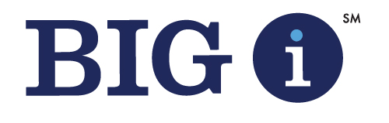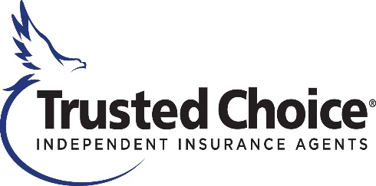

Big “I” Mid-Year Meeting
Hyatt Regency San Antonio Riverwalk
San Antonio, Texas
May 19 – 22, 2021

Safety Precautions
As of March 12, 2021

The safety of our meeting attendees is paramount. We are taking the following precautions, adhering to current state of Texas requirements (Addendum to Declaration No. 8) in place indefinitely and CDC recommendations and checklists. Please see the website for the City of San Antonio for additional guidelines and information.

Acknowledgement of Enhanced Safety and Health Measures:
Registration and attendance at, or participation in, the Big “I” Mid-Year Meeting in person constitutes an agreement by the registrant to abide by IIABA’s and the host property's efforts to comply with current CDC recommendations (and any state of Texas requirements) and to engage in certain health-and-safety-beneficial conduct while attending the event as requested by IIABA (including wearing a mask, engaging in appropriate physical distancing, not attending the event if feeling sick, showing certain symptoms or after being exposed to an individual with COVID-19).

Guidelines and Precautions

General Information
- All attendees are encouraged to bring their own personal protective equipment (e.g. masks and hand sanitizer) for their personal use.
- IIABA will provide attendees with complimentary masks and hand sanitizer in the registration area when name badges are picked-up. Any mask or hand sanitizer is provided “as-is” with no warranties or representations as to the quality or efficacy of these items.
- Name badges will be pre-stuffed in badge holders and a lanyard will be included in the name badge envelope.
- No handouts, ribbons or other materials will be present in the registration area.
- It’s mandatory to register in advance in order to accept the meeting waiver. You must register to be able to attend the meeting and on-site registration won’t be available.

Face Mask and Social Distancing
- Due to our cooperative agreement with the meeting facilities, a mask covering both the nose and mouth will be required at all times while inside the hotel unless eating or drinking, or while in your guest room. Guests who are not wearing face coverings indoors will be politely asked to wear one, and like at all Hyatt hotels, face masks will be made available by the hotel to guests who do not have one.
- Please see this link for the city of San Antonio’s mask information.
- State and municipal health guidelines stress that, whenever possible, all persons should leave at least 6 feet (approximately 2 meters) of space to the person closest to them. Social distancing guidelines are prominently placed throughout the hotel.

General Hotel Cleanliness
- The hotel requires team members to wear face masks at all times – and additional personal protective equipment based on job specifications.
- In an effort to enable safe travel, Hyatt supports the American Hotel & Lodging Association’s recently expanded Safe Stay initiative and traveler checklist, which for the foreseeable future include the wearing of face coverings in indoor (and outdoor if city/state mandated) public spaces and practicing social distancing.
- Hyatt has released its Global Care & Cleanliness Commitment guidelines.
- The Hyatt Regency San Antonio Riverwalk Know Before You Go guidelines.
- Hotel staff members have wellness and temperature checks upon arrival.
- Touchless hand sanitizer stations are located around the hotel.
- Public bathrooms will be cleaned frequently (more than once an hour).

COVID-19 Response and Protocols
- If a guest begins to feel ill, he/she will be strongly encouraged to contact health authorities in order to be tested for COVID-19. Prior to and after being tested, a guest with a suspected or confirmed case will be required to remain in his/her guest room until the guest can depart from the hotel to return home or go to a medical facility. If a guest tests positive, the hotel strongly encourages the guest to seek a medical facility as the hotel is not designed or equipped to handle medical care. If a guest is under quarantine, the guest may reach out to the front office to talk through options for food delivery outside his/her guest room door. Once vacated, a room occupied by a guest who is suspected of having or has been diagnosed with COVID-19 will be removed from service to undergo a detailed cleaning protocol. The guest room will not be returned to service until the room has been disinfected, and consistent with the guidance issued by local health authorities.

Hospital:
Metropolitan Methodist Hospital
1310 McCullough Ave
San Antonio, TX 78205
210.757.2200

Urgent Care:
Concentra Urgent Care
400 E Quincy St
San Antonio, TX 78205
210.472.0211

Test Facilities:

Please review this link for all of the options.

Guest Rooms
- The following options are available via the World of Hyatt app – please download to take advantage:
*Digital key
*Digital check-in
*Account access
*Points balance & earned rewards
*Hotel stay bill
*Curated meditations from Headspace
- Every guest room is thoroughly cleaned and disinfected prior to your arrival. During your stay, hotel will not provide housekeeping automatically every day. If you wish to receive daily housekeeping refresh service, please let the guest services team know. They will be happy to schedule service according to your preferences. For a longer stay, your guest room will automatically be cleaned after every 4th night.
- Coffee makers and minifridges remain in guest rooms. All paper (menus, magazines, etc.) has been removed.
- Early check-in and late check-out will be extremely limited as housekeeping requires additional time to clean rooms in-between guests.

Meeting Spaces
- Meeting spaces will be set according to social distancing guidelines.
- Meeting rooms are disinfected after each meeting. Please do not leave anything in the meeting rooms when you leave.
- Water stations are not available due to current recommendations. Bottled water will be available in event space if provided by the group or in MKT Place on the Lobby Level.
- Social distancing and one-way signage are present.
- Pens and writing pads won’t be available.

Meal Functions
- A meal served buffet style in the past will now have food stations and will be cafeteria style with hotel staff serving attendees (partitions and sneeze guards will be present).
- Some coffee stations will be staffed by hotel team members and others will be self-service. For those that are self-service, please use the paper provided to touch the coffee urn spigot.

Miscellaneous/Other
- Valet and self-parking will be available.
- Elevator information:
*Elevator button panels are disinfected at frequent intervals.
*4 guests will be allowed per elevator.

