Subject: Celebrate Community Service with the Young Agents!
You are invited to join the GIVE Movement!
The Big “I” Young Agents are asking state associations, agents, companies to give back to the community the week of June 1-8 and to share their activity with national.
This week is all about small things making a big difference!
Who can GIVE?
Anyone, anywhere is encouraged to get involved. This event is designed to unite state associations, agents, carriers, vendors and the community in an amazing and rewarding way! Trusted Choice® agents are involved in the community and we need to document and celebrate our efforts.
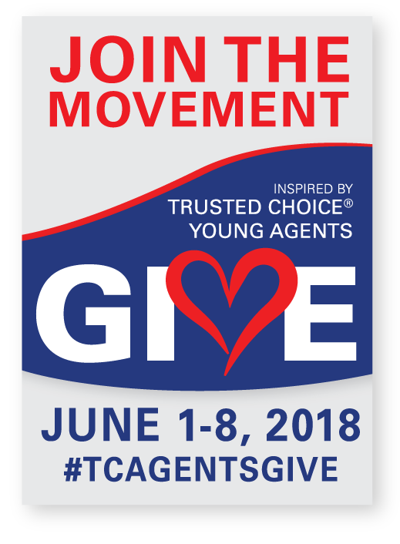
How do you get involved?

- Determine the charity/activity (collection jar/site, volunteer activity or more) Find ideas here!
- Complete the online form or schedule a call with Susie Bonner (Once you share your activity, we’ll share it on the national Facebook page.)
- Utilize our GIVE resources
- Join our Facebook event
- Give back and document activities on social media #TCAGENTSGIVE
- Report back after the event and let us know how you did!

Why GIVE?
Big “I" Trusted Choice® Young Agents make a difference in the community and from June 1- 8, 2018 we are going to celebrate the generosity of our industry. The GIVE MOVEMENT is a week-long campaign dedicated to giving back to the community. During this week we are asking anyone, anywhere to give back--volunteer, host a fundraiser, be a collection site for a local charity. This week is all about small things making a big difference.
“The GIVE MOVEMENT is a win for our associations, agencies and partners. It's a win for our community and a win for the future. I am so proud of everything independent agents do in their hometown—it's time to celebrate our efforts."
Big “I" national Young Agents Committee Chairman, Joe Hamilton, Hal Rakowski Insurance, California
** Inspired by the Young Agents Committee of the Independent Insurance Agents of Illinois #IIADayofGiving
For more information contact Susie Bonner or a member of your national Young Agents Committee.
P.S. Stay tuned for a Make-A-Wish online fundraiser hosted by the national Young Agents Committee.

